 | 1980 | Ripe!!!  RSO |  | (1)
 | 1983 | Streetcar Named Desire  Capitol |  | (1)
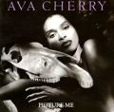 | 1987 | Picture Me  Capitol |  | (1)
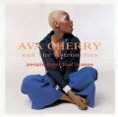 | 1995 | People From Bad Homes  Griffin |  | (5)
 | 1997 | Spend the Night  J-Bird Records |  | (2)
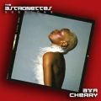 | 2009 | The Astronettes Sessions  Black Barbarella / Easy Action Records

